Delly duck activities
WORD SEARCH

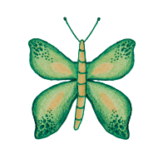
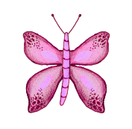
B | S | W | A | N | S | U | L | T | E | R
U | G | L | N | C | E | D | I | Y | L | F
A | B | N | E | G | O | S | T | U | F | S
G | Q | F | S | A | F | E | T | O | O | R
B | U | T | T | E | R | F | L | Y | S | E
H | I | R | O | G | V | E | E | I | T | T
O | L | A | U | G | T | Q | C | P | E | T
M | L | O | V | E | W | S | H | T | R | E
E | Q | A | D | O | P | T | I | O | N | L
D | E | L | L | Y | D | U | C | K | A | Q
S | W | I | Q | U | A | C | K | E | R | S
C | A | R | I | N | G | G | O | O | S | E

ADOPTION
BUTTERFLY
CARING GOOSE
DELLY DUCK
EGG
FOSTER
HOME
LETTERS
LITTLE CHICK
LOVE
NEST
QUACKERS
QUILL
SAFE
SWANS

